Material Flow Description

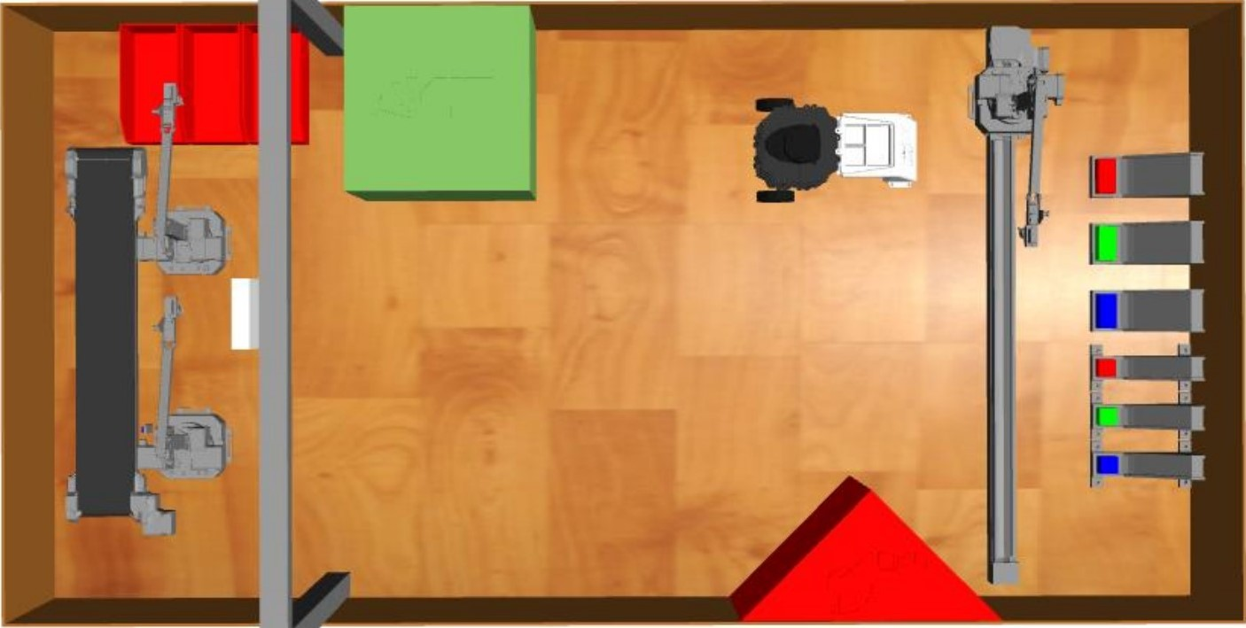

**1**

**3**

**2**

1. uArm1 gets objects from slides

a) TurtleBot moves to loading bay / calibrates its position.  
b) uArm1 slides in front of the desired slide.   
c) uArm1 gets object and slides back in front of the TurtleBot.  
d) uArm1 puts object on the TurtleBot.  
e) If there are more objects left in the order and TurtleBot isn’t full yet: repeat from step b).

2. TurtleBot delivers object to collection area

a) TurtleBot moves itself to the uArm2.  
b) TurtleBot positions itself in front of uArm2.

3. Objects are collected and stored in the boxes

a) uArm2 takes object from TurtleBot.  
b) uArm2 puts the object on the conveyor.  
c) Conveyor moves the object.  
d) uArm3 takes object from conveyor and puts it into the desired box.  
e) If there are more objects on the TurtleBot: repeat from step a)

Material Flow based on Modular Material Handling (MMH):

uArm1 TurtleBot uArm2 Conveyor uArm3

Move

Get

Put

Put

Get

Move self

Put/Get

Move self

Get